
Republic of the Philippines
DEPARTMENT OF EDUCATION
Region VI – Western Visayas

LESSON PLAN IN FISH PROCESSING GRADE 10

- Objectives

- Content Standards

The learner demonstrates understanding in operating appropriate equipment for food (fish) processing.

- Performance Standard

The learner demonstrates independently the given procedures in basic operation of equipment needed in food (fish) processing including recognition of functional and quality equipment and its maintenance following specific procedures and instructions.
- Learning Competencies

Operate machine/equipment in a safe and controlled manner in
accordance with OHS requirements and manufacturer’s specification

- Explain the procedures in operating a pressure cooker
- Operate a pressure cooker
- Appreciate the importance of a pressure cooker
- Content

Operating machine/equipment specifically a Pressure Cooker

CodeTLE_AFFP10 OE-If-j-IIa-e-2

- Learning Resources

- References
Teachers Guide : K to 12 – Technology and Livelihood Education Fish
Processing 10 CG, Pg.15
Learners Materials : K to 12 – Technology and Livelihood Education Fish
Processing 10, Page 43-94
Textbook :

- Additional Materials from Portal
CBLM TLE-AFA LG GR. 10 Food and Fish Processing
www. lrmds.deped.gov.ph

- Other Learning Resources
Pressure cooker, laptop, multimedia projector, speaker, multimedia
presentation, manila paper, activity sheets and pentel pen, picture and video
taken from internet from https://www.youtube.com/watch?v=TWV3FbgPPXo

- Procedures

- Reviewing Previous Lesson

Workplace Safety Charades

Divide the class into two (2) groups. Students select their leader to act out the word given to them. The rest will guess the word being act. Have the groups take turns in acting out their assigned words or phrase. Set 60s for each word/s. The groups with the highest points win.

1. Apply lubricant
2. Do not touch hot surfaces
3. Read manufacturers specification
4. Keep records of all equipment

- Establishing a Purpose for the Lesson

Semantic Web through 4 Pics in 1 Word

The teacher will show pictures and ask the students to guess the word and tell something about it.
Pressure
Cooker
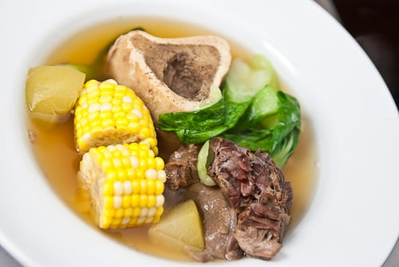
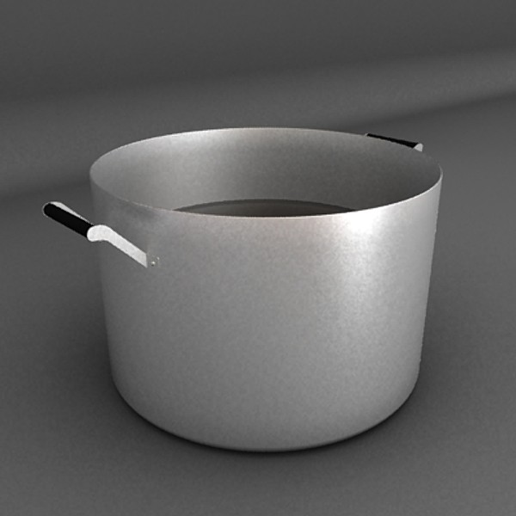

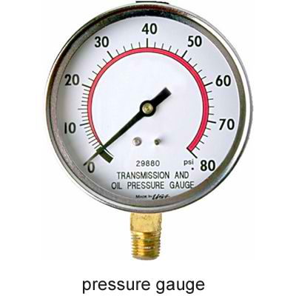

C. Presenting Examples or New instances of the Lesson

Today you will learn about the procedures on how to operate a pressure
cooker.
The teacher will flash on the screen the learning objective.
The teacher will show an actual pressure cooker
Ask:
- Who among you are familiar with this equipment?
- Were you able to use it? Can you share your experience on how to use this equipment?

- Discussing new concepts and practicing new skills #1
Group Activity

Divide the class into two (2) groups. Ask them to arrange the following
procedures accordingly or in its proper order in operating a pressure cooker. Ask
a leader to present their output. The teacher will move around to assist the
students
Ask:

1. How did you come up with the following procedures?
2. What will happen if you interchange the correct procedures in
operating the pressure cooker? Would you please justify your
answer.
3. What will happen if we put on the machine before plugging it to the
outlet?

- Discussing new concepts and practicing new skills #2
Video Clip Presentation
How pressure cookers work?

Teacher Demonstration
Ask:
1. What have you seen in the video?
2. Do you think it is important to correctly operate a pressure cooker?
3. When you learn today, what will you do with the information?
When will you share it?
- Developing New Mastery

Operate a pressure cooker using RUBRICS

- Finding Practical application of Concepts and Skills in Daily Living
The teacher will ask the following questions:
1. How did you find the activity?
2. How did you come up with the expectation of the activity?
3.. How are you going to respond to the following Scenario?
a. Petcock produced sound
b. Loose pressure cooker cover

- Making Generalization and Abstractions about the Lesson
Ask:
- What have you learned today?
- How do you operate the pressure cooker?
- Evaluation Learning
Performance on the operation of the pressure cooker using the Rubrics

- Additional Activities for Remediation
Ask:
1. What is a can sealer?
2. What are the different parts of a can sealer?

V. Remarks
VI. Reflection
No. of learners who earned 80% in the evaluation
No. of learners who require additional activities for remediation who scored below 80%
Did the remedial lessons work? No. of learners who have caught up with the lesson
No. of learners who continue to require remediation
Which of my teaching strategies worked well? Why did these work?
What difficulties did I encounter which my principal or supervisor can help me solve?
What innovation or localized materials did I use/discover which I wish to share with other teachers?

Prepared by:

CHERYL T. TAMPOS
Master Teacher I

Checked:

GREGONIO A. BATILARAN, JR.
EPS, EPP/TLE

